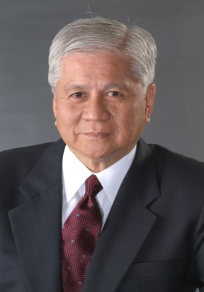

KEYNOTE SPEAKER

ALBERT F. DEL ROSARIO
Former Ambassador Extraordinary and Plenipotentiary
of the Republic of the Philippines to the United States of America

A well-known businessman, Amb. Albert F. del Rosario was Philippine Ambassador to the United States from 2001 to 2006. He served as Secretary of the Department of Foreign Affairs (DFA) from 2011-2016.
Amb. del Rosario was born in Manila in 1939. He finished his elementary and high school education in New York City and graduated from New York University with a Bachelor of Science in Economics Degree.
Prior to joining government, Ambassador del Rosario’s business career of over four decades has spanned the insurance, banking, real estate, shipping, telecommunications, consumer products, retail, pharmaceutical and food industries.
Amb. del Rosario has held numerous corporate chairmanships and directorships, including top level positions at the Metro Pacific Corporation, the Philippine Indocoil Corporation, the Fort Bonifacio Development Corporation, and the Philippine Long Distance Telephone Company.
Amb. del Rosario has been actively involved in promoting social and civic causes. He is Chairman of the Philippine Cancer Society National Fund Drive, the Free Rural Eye Clinic, and the Makati Foundation for Education. He is also a keen supporter of sports and is the incumbent Chairman of the Korean Hwa Rang Do Martial Arts Association of the Philippines with a 1st Degree Black Belt.
As a leading executive in the private sector, Amb. del Rosario joined official delegations during the State Visits of President Corazon C. Aquino to the United States and of President Fidel V. Ramos to Indonesia.
In 1991, Amb. del Rosario received the Philippine Army Award from President Aquino for his initiatives as Chairman of the Makati Foundation for Education. In early 2001, he received the Edsa II Heroes Award from President Gloria Macapagal-Arroyo in recognition of his efforts in promoting Philippine democracy.
Amb. del Rosario is married to Gretchen de Venecia. They have five children.
*********************

